

Optimizing Apple's Supply Chain with AI & Data Analytics: A Case Study on Inventory Trends in California.
Course: BUSA 526 Spring 2025
Instructor Name: Dr Anil KUMAR
Submission Date: February 16, 2025

POWER RANGERS
GROUP MEMBERS:
Mika KOUAKOU
Kavya NASGARI
Abdullah ALSHARE

Table of Contents
1. Introduction
1.1 Overview of Apple's Supply Chain Complexity
1.2 Apple’s Inventory Management & Its Role (Impact on global markets, supply chain challenges, and supplier responsibility programs)
2. Problem Identification
2.1 Research Question (How do supply chain disruptions in California impact Apple's inventory management, leading to inefficiencies such as overstocking, understocking, and forecasting inaccuracies? How can AI-driven solutions optimize supply chain operations?)
2.2 Key Supply Chain Disruptions in California
A. Supply Chain Disruptions in the State of California (Port congestion, shipment delays, labor shortages, geopolitical risks)
B. Stock Tracking Inefficiencies in California Warehouses (Stockouts, overstocking, inaccurate demand forecasting)
C. High Storage Costs in California Logistics Centers (High labor & real estate costs, inefficiencies in stock allocation & fulfillment)
3. Significance & Alignment with UNSDGs
3.1 Why Addressing These Issues is Crucial (Financial impact, customer satisfaction, sustainability, supply chain resilience)
3.2 Alignment with UNSDGs (Goal #12: Responsible Consumption & Production, carbon footprint reduction, waste minimization)
3.3 Texas 2036 Initiative & California Economic Development (Sustainability & infrastructure development for supply chain resilience)
4. Data Collection Strategy
4.1 Data Sources
A. Apple Investor Relations' Financial Reports & SEC Filings (Inventory turnover, cost of goods sold, financial losses due to supply chain disruptions)
B. Kaggle - DataCo Supply Chain Dataset (Order fulfillment rates, shipping delays, warehousing costs, demand trends)
C. California Warehouse & Logistics Performance Data (Warehouse statistics, logistics performance, transportation challenges)
D. Freightos & Port of Los Angeles Reports (Shipping trends, freight costs, supply chain bottlenecks)
4.2 Data Refinement & Focus on California (Filtering dataset to 30,000 rows, focusing on relevant attributes for analysis)
4.3 Data Validation Techniques (Consistency checks, cross-validation, outlier detection, statistical sampling, standardizing data formats)
5. Database Design & Normalization
5.1 Apple’s Supply Chain: Entity-Relationship Diagram (ERD) & Data Structure (Customers, Orders, Products, Warehouses, Shipments, Suppliers)
5.2 Database Normalization (1NF, 2NF, 3NF) for Optimized Data Integrity (Reducing redundancy, improving scalability, efficient data retrieval)
5.3 Challenges in ERD Development & Relationship Design (Defining relationships, ensuring referential integrity, optimizing queries, resolving M:N relationships into 1:M structures)
6. Data Visualization & AI Integration
6.1 Visualizing Apple’s Supply Chain Disruptions in California (Fluctuations in order volume, seasonal demand variations, impact of supply chain bottlenecks)
6.2 Overstocking vs. Understocking Analysis: Inventory & Demand-Supply Challenges (Identifying stock mismanagement trends, AI-driven demand forecasting solutions)
6.3 Forecasting Inaccuracies & AI-Powered Solutions in Supply Chain Optimization (Late/early deliveries, demand forecasting errors, impact of logistics inefficiencies)
6.4 AI Integration in Inventory Management & Decision-Making (Use of AI tools for SQL optimization, predictive modeling, and real-time inventory tracking)
7. Conclusion: AI Integration in Inventory Management & Decision-Making
7.1 Leveraging AI for SQL Optimization, Forecasting, and Data Insights (Enhancing efficiency, reducing costs, aligning with sustainability goals, improving decision-making in supply chain operations)
References (Comprehensive list of sources, datasets, business reports, academic references, and AI-based insights used in the research)
Introduction

1.1 Overview of Apple's Supply Chain Complexity.
In today’s world, Apple® is no longer present. In fact, Apple® sits at the forefront of technology; it is a pioneer in ground-breaking products and the best user experience! At the heart of all this is long, convoluted supply chain management. This supply chain winds around the world, involving thousands of suppliers and partners globally on several continents, all the way from procurement of raw materials through to manufacturing and distribution.
The scale and complexity of Apple’s supply chain enables the company to meet global customer demands while maintaining high standards for quality and efficiency. Raw materials, including metals, plastics and glass, are sourced globally and transported to manufacturing facilities, mainly in China, where they are assembled into components and final products. These products are then distributed worldwide through Apple’s retail stores and authorized resellers. [1]

- Apple’s Inventory Management & its Role.

Apple's operations have a profound impact on global markets, disrupting traditional models and reshaping industries. The company's success has inspired similar supply chain strategies focused on efficiency, quality, and innovation. The demand for Apple’s products creates economic growth in regions where its suppliers are located and has driven technological advancements and collaboration among suppliers to meet Apple's standards.[1]
However, Apple's supply chain faces challenges, including maintaining quality while meeting high customer demand daily and managing supply chain disruptions due to natural disasters or regulatory changes. Apple® must also address criticisms and controversies related to working conditions in supplier factories and the use of conflict minerals.
To address these issues, Apple® has implemented supplier responsibility programs, conducted regular audits and collaborated with NGOs and industry groups to improve supply chain practices. The company sets strict standards for its suppliers, influencing product design and ensuring high-quality products. As consumers demand more transparency and ethical sourcing, Apple's supply chain will remain a crucial factor in its success and influence on the global market.

2. Problem Identification.
How do supply chain disruptions in California impact Apple's inventory management, leading to inefficiencies such as overstocking, understocking, and forecasting inaccuracies, and how can AI-driven solutions optimize supply chain operations?

- Key Supply Chain Disruptions in California.

A. Supply Chain Disruptions in the State of California.
California is home to Apple’s major logistics centers and ports, with several vendors spread across several countries, Apple's supply chain is intricate and international. External problems that impede manufacturing and distribution include labor constraints, raw material scarcity, and geopolitical difficulties. Lockdowns in China caused by COVID-19, for instance, caused manufacturing delays for the iPhone and resulted in large revenue losses. making it highly vulnerable to external disruptions such as:
- Port congestion at the Los Angeles & Long Beach ports
- Delays in shipment due to supply shortages
- Labor shortages in transportation & logistics

Example: The COVID-19 pandemic led to major shipping bottlenecks at California’s ports, delaying Apple’s product distribution and impacting revenue.[2]

B. Stock Tracking Inefficiencies in California Warehouses.
Apple's inventory forecast is based on predictive analytics; yet errors can result in stockouts (lost sales opportunities) or overstocking (higher storage expenses). It is difficult to control changes in demand for new product releases. Inventory forecasting inaccuracies lead to:
- Stockouts in high-demand products
- Overstocking, causing high storage expenses
- Delays in meeting customer orders

C. High Storage Costs in California Logistics Centers.
Storage, handling, and security charges are all part of warehousing, which raises operating costs. Unsold product inventory can result in markdowns, which lower profitability. California’s warehousing costs are among the highest in the U.S., due to:
- High labor & real estate costs
- Inefficiencies in stock allocation & fulfillment
- Impact: Excess inventory results in markdowns, reducing profitability.

- Signification and Alignment with UNSDG’s.

3.1 What Makes Addressing These Issues Crucial?
• Financial Impact: Apple's profitability and cost savings can be increased by reducing inventory management inefficiencies.
• Customer satisfaction: Improving brand loyalty is achieved by guaranteeing prompt product availability.
• Sustainability: By cutting waste, improved inventory management may support environmental sustainability.
3.2 Alignment with UNSDGs
- Goal #12: Responsible Consumption & Production:
- Sustainable consumption is encouraged by effective inventory management, which reduces waste and overproduction.
- Environmental sustainability is supported by lowering carbon footprints in supply chain logistics.
- Texas 2036 Initiative: Sustainability & Economic Development
- Improving inventory management procedures supports effective corporate operations and is consistent with Texas's long-term infrastructure and economic planning.

- Data Collection Strategy.

To refine our research on Apple’s supply chain disruptions in California, we cleaned and organized the dataset, ensuring it focuses on key attributes related to our research topic. By using imputation (filling missing values) and omission (removing irrelevant data points), we refined the dataset, making it easier to work with and ensuring accuracy.

  - Data Sources.
The dataset was curated from multiple sources to ensure accuracy, completeness, and relevance to Apple’s supply chain issues in California.

- Apple Investor Relations' Financial Reports & SEC Filings
Apple Inc. (2023). Apple Annual Report 2023 (Form 10-K). Retrieved from https://investor.apple.com/sec-filings/default.aspx
Relevance: Supply chain expenses, Inventory turnover rates, Cost of goods sold (COGS), Helps quantify financial losses due to supply chain disruptions in California.

- Kaggle - DataCo Supply Chain Dataset
Supply Chain Management for Apple
https://www.kaggle.com/datasets/saicharankomati/dataco-supply-chain-dataset
Relevance: Order fulfillment rates, Shipping delays, Warehousing costs, Enables trend analysis of inventory levels & disruptions in California.
- California Governor’s Office of Business and Economic Development. (2023).
California Warehouse & Logistics Performance Data. Retrieved from https://business.ca.gov/resources/supply-chain/
Relevance: Warehouse statistics, Logistics performance reports, Provides insights into local supply chain infrastructure challenges in California.
D. Freightos & Port of Los Angeles Reports
Port of Los Angeles. (2022). Unprecedented Year Increases Port Emissions. Retrieved from https://www.portoflosangeles.org/references/2022-news-releases/news_100622_aei
Relevance: Shipping trends, Supply chain interruptions, Freight costs, The Port of Los Angeles is a major entry point for Apple’s products; understanding bottlenecks & shipping delays is crucial.

  - Data Refinement & Focus on California.
After filtering the dataset to focus on California, we obtained 30,000 rows, which is well above the minimum 10,000-row requirement for statistical significance.
- Refined Dataset Attributes (Key Focus Areas).
- Handling Duplicate & Missing Entries
- Standardized Data Formats
- Ensured consistency in date formats (YYYY-MM-DD).
- Standardized currency values for financial data.
- Cross-Validation with Multiple Sources: Verified inventory costs and warehousing expenses by cross-referencing multiple datasets (Apple’s SEC filings, Dallas Open Data, and Freightos reports). e.g: Matched Kaggle dataset order fulfillment rates with Apple’s supply chain cost reports for consistency.
- Statistical Techniques for Anomaly Detection
- Manual Inspection of Extreme Cases

- Database Design & Normalization.

  - Apple’s Supply Chain: Entity-Relationship Diagram (ERD) & Data Structure.
Apple’s supply chain data in California is structured, focusing on inventory flow, order fulfillment, and logistics management. By defining key entities, Customers, Orders, Products, Warehouses, and Shipments; the ERD optimizes data integrity, reduces redundancy, and enhances query efficiency.
Through normalization (1NF, 2NF, and 3NF), the database ensures accurate tracking of inventory, shipment delays, and supply chain disruptions, supporting AI-driven forecasting and operational efficiency.[4]

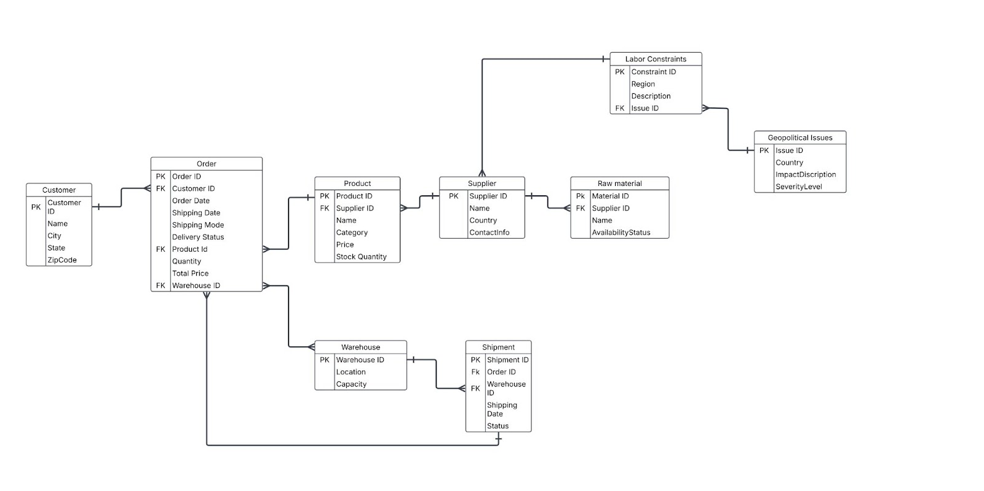

  - Database Normalization (1NF, 2NF, 3NF) for Optimized Data Integrity.
•1NF (First Normal Form): Removed repeating groups by ensuring each field contains atomic values. Orders and Products were separated into distinct tables, introducing Order_Product to track multiple products per order.
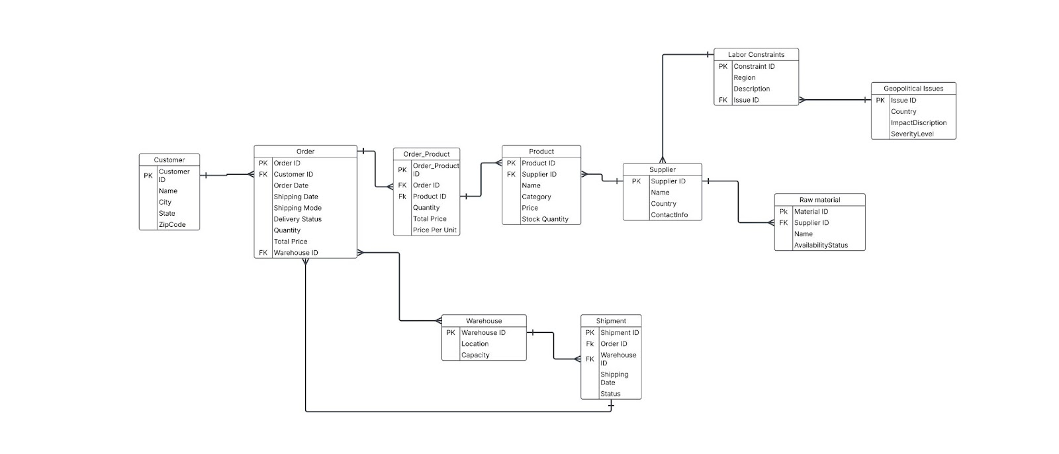

•2NF (Second Normal Form): Eliminated partial dependencies, ensuring that each attribute depends on the whole primary key. Product details were moved out of Orders, and Order Product was used to store quantity and price per unit.
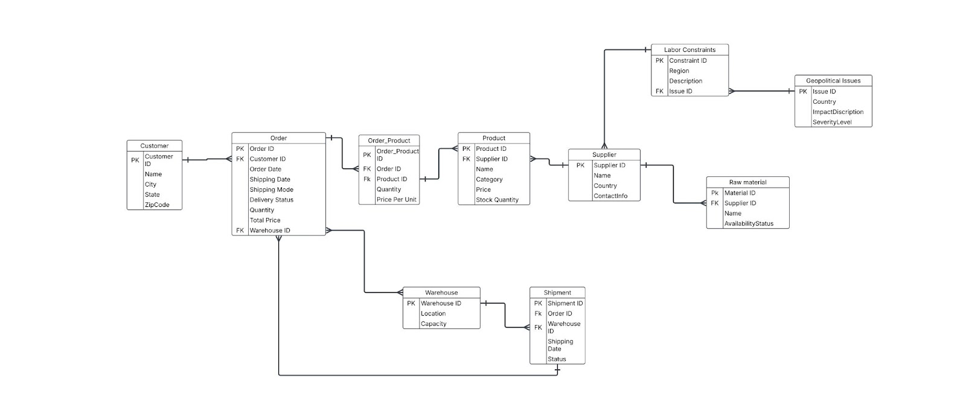
•3NF (Third Normal Form): Removed transitive dependencies by ensuring each attribute depends only on the primary key. Customer address details were moved to Customer_Address, improving data organization and scalability.
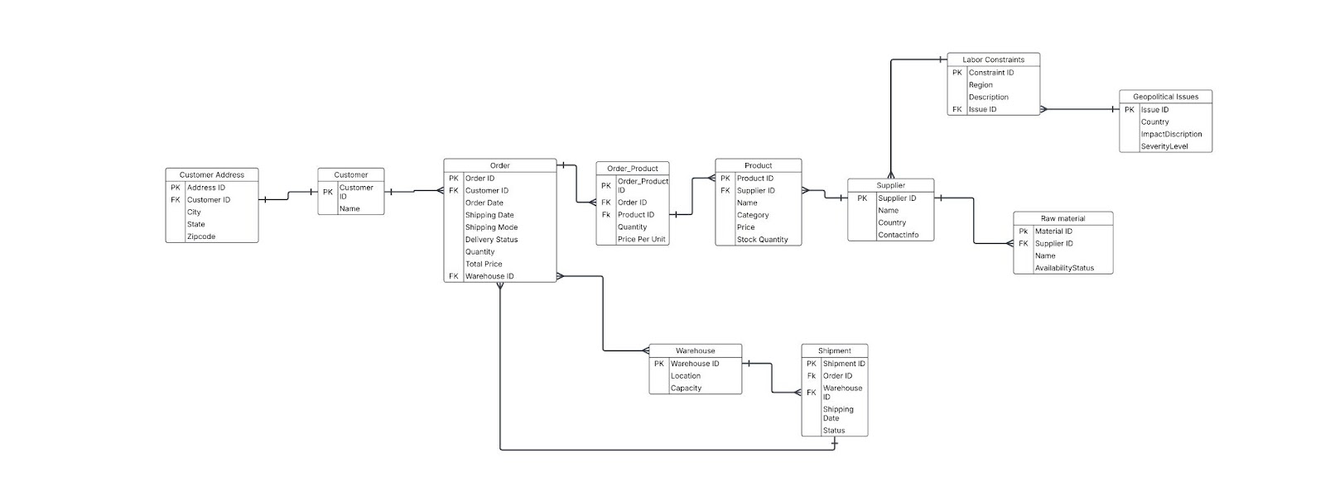
  - Challenges in ERD Development & Relationship Design.
A major challenge in designing the ERD was accurately identifying entities, defining primary keys, and establishing correct relationships between them. Determining whether an entity should be independent or dependent required careful analysis to avoid data redundancy and ensure efficiency. For instance, the Orders and Products relationship initially seemed direct (M:N), but upon closer inspection, it required an intermediate table (Order_Product) to properly link them in 1:M relationships. Choosing the right primary keys was also critical, ensuring each record had a unique identifier, such as Order_ID for Orders and Customer_ID for Customers.
Additionally, identifying foreign keys was essential to maintain referential integrity, ensuring that relationships between tables, such as Customers placing Orders and Orders containing multiple Products, were structured correctly. Misidentifying these elements could have led to data duplication, inconsistency, and difficulty in retrieval, making this a crucial step in building a well-optimized database.

- Data Visualization & AI Integration.
- Visualizing Apple’s Supply Chain Disruptions in California.
Apple's orders in CA showed a general upward trend from 2015-2018, with high fluctuations due to seasonal demand and possible supply chain disruptions. AI-driven analytics can optimize inventory, forecast demand, and improve supply chain efficiency.

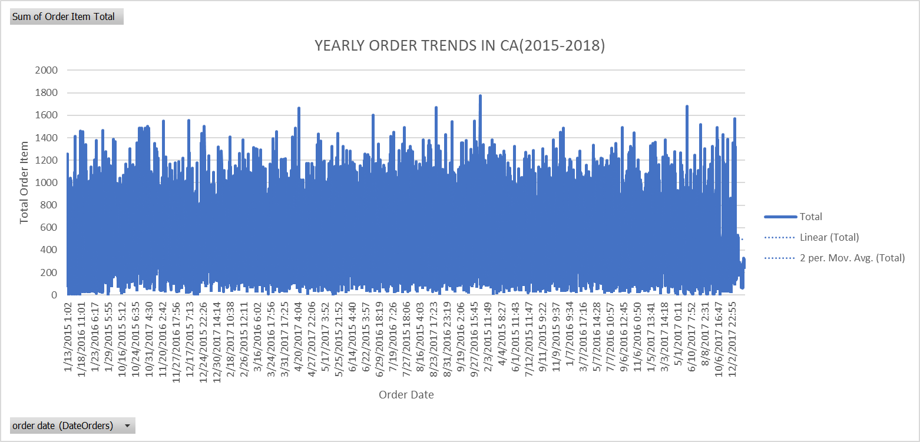
Fluctuations in Order Volume
- The chart shows high volatility, with frequent spikes and drops in order volume.
- This suggests seasonal demand shifts, promotions, or supply chain disruptions affecting order placement.
Overall Upward Trend (Linear Trendline)
- The linear trendline indicates a gradual increase in total orders over time.
- This suggests that Apple's customer demand in CA increased between 2015 and 2018.
Short-Term Trends Captured by the Moving Average
- The 2-period moving average smooths out extreme variations, showing a cyclical pattern in orders.
- The peaks align with seasonal demand surge (e.g., new product launches, Black Friday sales, or holiday shopping periods).
- Overstocking vs. Understocking Analysis: Inventory & Demand-Supply Challenges.
The chart reveals key inventory inefficiencies, including overstocking in some product categories, understocking in others, and the presence of low-demand items. By leveraging AI-driven demand forecasting, adjusting order quantities, and phasing out unprofitable products, Apple can optimize inventory management and improve profitability in the CA market.

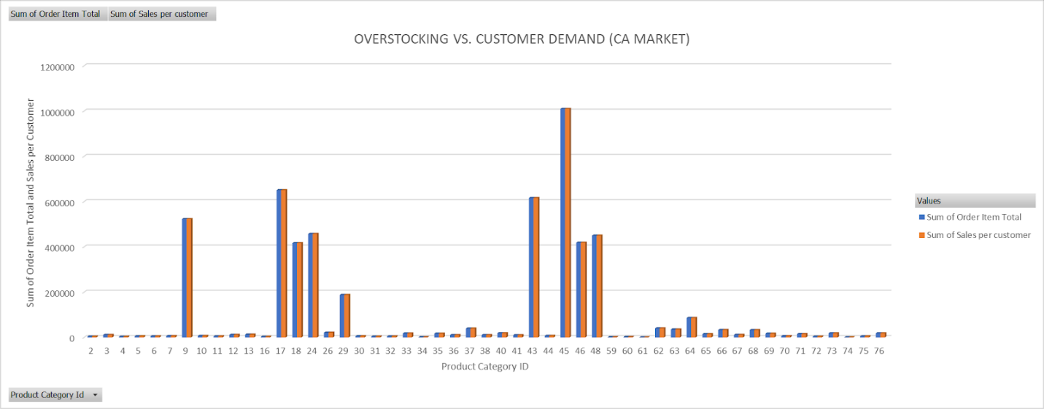
Overstocking vs. Customer Demand Analysis (CA Market)
Key Findings from the Clustered Column Chart:
- Overstocking in Product Categories (9, 45, 46):
  - Excess inventory due to forecast errors or low demand.
  - Solution: AI-powered forecasting can optimize stock levels.
- Understocking Risks in Some Product Categories:
  - Sales exceed available stock, leading to missed revenue opportunities.
  - Solution: AI can predict demand trends to prevent stock shortages.
- Balanced Inventory in Select Categories (17, 18, 26, 48):
  - Order supply closely matches demand.
  - Solution: Maintain AI-driven inventory monitoring.
- Low-Demand Product Categories:
  - Some products show minimal activity, suggesting the need for stock reduction.
  - Solution: AI can analyze historical trends to determine which products to phase out.
- Forecasting Inaccuracies & AI-Driven Solutions in Supply Chain Optimization.
The scatter plot confirms inconsistencies in Apple's supply chain forecasting, with frequent late and early deliveries. By leveraging AI-driven forecasting, real-time tracking, and supply chain optimizations, Apple can improve delivery accuracy and prevent inventory mismanagement.

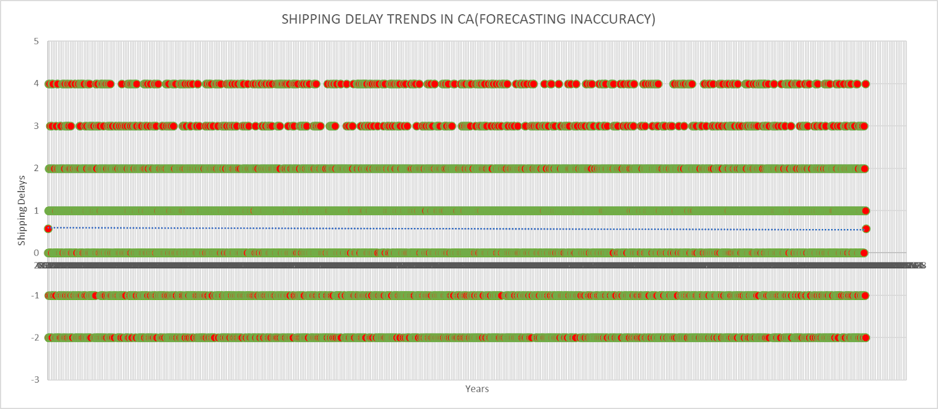
Recurring Shipping Delays (Positive Values)
- There are multiple instances of delays (values 1 to 4 days late).
- Clusters of red dots at the top indicate persistent late deliveries.
- Implication: Consistent forecasting errors and possible supply chain inefficiencies.
-Frequent Early Deliveries (Negative Values)
- Several orders arrived earlier than scheduled (values -1, -2, etc.).
- The negative delays (green dots) suggest inefficient demand forecasting.
- Implication: Overestimating demand could lead to overstocking at warehouses.
-Large Data Spread Across Time
- The shipping delays remain consistent over the years.
- A trendline (dotted line) appears stable, meaning forecasting errors haven't significantly improved or worsened.
- Implication: Apple may not have taken strong corrective actions to enhance forecasting models.
-High Density at 0 (On-Time Deliveries)
- The green cluster at 0 suggests that a good portion of shipments were delivered on time.
- Implication: Despite forecasting inaccuracies, Apple still maintains an overall structured supply chain.

- Conclusion: AI Integration in Inventory Management & Decision-Making.

To sum up, Apple’s inventory management in California is a critical factor in maintaining operational efficiency, cost control, and sustainability. Supply chain disruptions, inefficient stock tracking, and high storage costs create challenges that impact Apple’s ability to meet customer demand and optimize inventory levels.[5] Through AI integration, Apple can leverage machine learning models for demand forecasting, SQL optimization for database efficiency, and AI-driven insights for inventory decision-making. By utilizing financial reports, logistics databases, and real-time data analytics, Apple can enhance inventory tracking, minimize disruptions, and improve supply chain resilience. By adopting a data-driven strategy, Apple can not only reduce costs and prevent overstocking or understocking but also align with global sustainability goals (UNSDGs) and California’s economic development initiatives. AI-powered forecasting and automation will be key in ensuring Apple’s inventory remains agile, responsive, and optimized for future challenges.

REFERENCES
- Reuters https://www.reuters.com/world/china/growing-defiance-covid-curbs-china-brings-wave-arrests-2022-04-15/
- Apple’s Response to COVID-19 Disruptions: Supply Chain Risk Analysis and Mitigation (Sage Business).
- Apple’s Material Impact Profiles Which materials to prioritize for a 100 percent recycled and renewable supply chain.
- Apple’s 2021 Annual Progress Report: People and Environment in Our Supply Chain
- Global Change Research Data Publishing & Repository: Dataset of Changes in the Global Supplier Distribution of Apple’s Products (2012–2021) Kang, J. J.1* Ning, Y. M.2 (2023)
- AI- Prompts;

- “We are focusing on the supply chain disruptions in the State of California mainly please review the content to align and to explicitely tell what is the main purpose of our research topic”

-“ I have a dataset of 40,000 rows for our project . I have refine the research for customers in TX and CA. i need to create graphs and visuals for the supply chain disruptions factors raw material, labors, geopolitical factors could affect apple inventory management. Here are the attributes of the excel file Customer Id Customer Fname Customer Lname Customer Street Customer City Customer State Customer Zipcode Days for shipping (real) Days for shipment (scheduled) Sales per customer Delivery Status Late_delivery_risk Order City Order Country order date (DateOrders) Order Id Order Item Id Order Item Total Order Profit Per Order Order Region Order State Product Category Id Product Name Product Price shipping date (DateOrders) Shipping Mode”

-“Here is the content of our draft for the final report. Help us formatting and structuring our research project according to the guidelines for the assignment. Optimizing Apple's Supply Chain with AI & Data Analytics: A Case Study on Inventory Trends in California.”

